**Concise summary of the machine learning methodology**

The experiments in this study were performed in two phases. First, an exploratory screening of the tentative search space of process conditions (cf. Table 1) was performed. This initial search space was selected based on expert considerations, intending to balance experimental feasibility and broadness of the search/parameter space. In total, 45 devices were synthesized within this space, and their approximate efficiency was measured crudely. Significant variations in the measured device efficiency were observed, and hence we decided to retain the selected set of process conditions for the eventual optimization campaign, i.e., phase two of this study. In total, 1.3 billion distinct combinations of process variables can be distinguished within this search space.

|  |  |
| --- | --- |
| Process variable | Total range (interval) |
| Volume NMP (ml) | 0 – 100 (5) |
| Volume DMF (ml) | 0 – 100 (5) |
| Volume DMSO (ml) | 0 – 100 (5) |
| Perovskite concentration (M) | 0.8 – 1.8 (0.1) |
| Annealing temperature (°C) | 100 – 160 (5) |
| Vacuum pressure (Pa) | 20 – 400 (10) |
| Vacuum pressure time (s) | 0 – 55 (2) |

During the second phase of the study, the experimental conditions were optimized with the help of Bayesian optimization. To increase the accuracy of the registered efficiencies in this part of the study, measurements were rigorously performed four times on independent samples for every single device, and the average was taken. To not waste resources, films with visually detectable defects were immediately discarded.

The initial sampling of the search space was performed manually, informed by the results from the preliminary screening, and with the aim of covering the ranges of the individual process variables to a reasonable extent, as well as trying to limit the number of solvents added to the precursor (cf. Fig. 1 for a visual representation of the coverage of every variable).

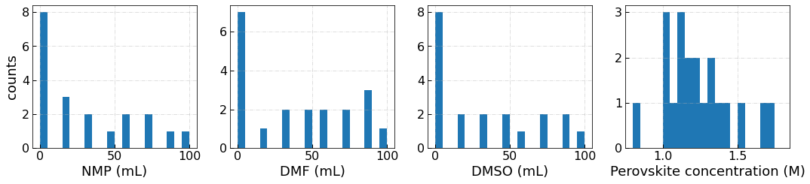

For the construction of the surrogate model, Gaussian Process regression with a matern52 kernel was selected. Matern52 is a flexible kernel, enabling it to treat potential discontinuities in the data better. Additionally, the kernel was selected in its anisotropic form, so that each of the kernel parameters could be tuned independently for each input variable, facilitating a stronger impact on the predicted output variable (the efficiency) by some variables compared to others.

To inform the selection of process condition combinations to acquire in the next batch, a compounded acquisition function was selected. In first instance, the utility function of upper confidence bound (UCB) was selected during the first couple of batches. Two probabilistic constraints were included in the acquisition function to incorporate the information about the film quality and the initial search space screening, in line with previous work by XXX. By introducing these constraints, one can expect to sample fewer points in the region where film quality is poor, or low device efficiency in the preliminary experiments. To be conservative, we softened the probabilistic constraints for the film quality to a range of 0.5 – 1, and for the initial screening to 0.8 – 1. The weighting factors were chosen to make the current data 5 times more important than the preliminary screening data, and the qualitative film quality information is considered half as important as the information of the actual efficiency measurements. Since the purpose of the probabilistic constraints is mainly to guide the model away from regions in the search space with a low probability of success, radial basis function kernels were used to model these constraints (radial basis functions are less flexible than matern52 kernels, but their more smooth/rigid behavior intuitively feels more appropriate to crudely define inaccessible regions of the search space).